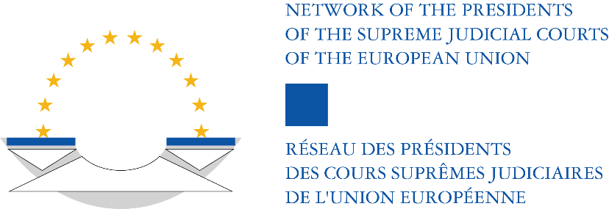

NETWORK OF THE PRESIDENTS OF THE SUPREME JUDICIAL COURTS OF THE EUROPEAN UNION

COLLOQUIUM OF THE NETWORK
&
JOINT MEETING WITH THE COURT OF JUSTICE OF THE EUROPEAN UNION

28 MARCH 2025
LUXEMBOURG

Topic 2: “GDPR supervision of judicial processing of personal data”

QUESTIONNAIRE

- Introduction

- The work of the courts goes hand in hand with the processing of personal data of people. Personal data of parties, witnesses, experts, judges, registrars, public prosecutors, lawyers, etc, may be processed by judges as well as the court administration when dealing with cases, deciding cases, providing judgments and decisions, and as part of their publishing activities.

- The General Data Protection Regulation (Regulation (EU) 2016/679) states in Recital 20:
“While this Regulation applies, inter alia, to the activities of courts and other judicial authorities, Union or Member State law could specify the processing operations and processing procedures in relation to the processing of personal data by courts and other judicial authorities. The competence of the supervisory authorities should not cover the processing of personal data when courts are acting in their judicial capacity, in order to safeguard the independence of the judiciary in the performance of its judicial tasks, including decision-making. It should be possible to entrust supervision of such data processing operations to specific bodies within the judicial system of the Member State, which should, in particular ensure compliance with the rules of this Regulation, enhance awareness among members of the judiciary of their obligations under this Regulation and handle complaints in relation to such data processing operations.”

- Article 55 (3) GDPR states that supervisory authorities shall not be competent to supervise processing operations of courts acting in their judicial capacity.

- The focus of this topic is on the GDPR supervisory role of specific bodies within the judicial systems of the Member States with regard to the processing operations of courts acting in their judicial capacity, hereinafter called “GDPR supervision of judicial processing of personal data”.
- So far, one judgment of the CJEU exists with regard to this role (ECLI:EU:C:2022:216). The Advisory Opinion of Advocate General Bobek (ECLI:EU:C:2021:822) mentions a Research Note from July 2018 on the “Supervision of courts’ compliance with personal data protection rules when acting in their judicial capacity”. This Research Note concluded, among other things, that it appeared that the vast majority of the Member States had satisfied the requirement to exclude from the competence of the national supervisory authority personal data processing carried out by the courts acting in their judicial capacity, but that the establishment of specific supervisory mechanisms was, in part, work in progress.

- The Network is a suitable place for sharing further developments in their establishment and for disseminating knowledge and best practices within national judiciaries on this supervisory role. A dialogue between the Court of Justice and the Network may contribute to clarifying what is expected under Recital 20 and Article 55 (3) GDPR. The upcoming Joint Meeting of the Network with the CJEU on 28 March 2025 in Luxembourg offers an opportunity to explore relevant issues and to share experiences and best practices.

- This questionnaire intends to gather information prior to the Joint Meeting, in order to prepare a report which will give more visibility on the current practice of GDPR supervision of judicial processing of personal data within the Member States and the European Union. The intention is to try to update the information in the abovementioned Research Note from July 2018 on the “Supervision of courts’ compliance with personal data protection rules when acting in their judicial capacity”. Furthermore, the questionnaire aims to collect information on legal practice concerning GDPR supervision of judicial processing of personal data within the Member States and the European Union. Finally, it intends to explore whether there is any relationship between this type of supervision and the role of non-judicial supervisory authorities regarding judicial processing of personal data.

B. Questions

1. Established supervisory mechanisms:
Please consider whether information regarding your country is included in the Research Note from July 2018 on the “Supervision of courts’ compliance with personal data protection rules when acting in their judicial capacity”. If yes, please answer question 1.a. If no, please answer question 1.b.

a. If yes, please indicate whether this information still reflects the supervisory mechanisms currently in place in your country; please provide an update on any developments since July 2018 in the establishment of specific supervisory mechanisms in your country for the supervision of courts’ compliance with personal data protection rules when acting in their judicial capacity.
b. If no, which specific supervisory mechanisms exist in your country for the supervision of courts’ compliance with personal data protection rules when acting in their judicial capacity?
2. Functioning of supervision:
a. Can you provide examples or any other information on the functioning within your country of the supervision of courts’ compliance with personal data protection rules when acting in their judicial capacity? For instance:
- examples of court decisions or judgments concerning that supervision,
- information included in annual reports concerning that supervision,
- examples on the handling of complaints regarding courts’ compliance with personal data protection rules when acting in their judicial capacity,
- examples of activities of established supervisory authorities dealing with anonymization or pseudonymization of a court decision or judgment,
- etc.

b. Does a non-judicial national GDPR supervisory authority undertake activities of supervision of courts’ compliance with personal data protection rules when acting in their judicial capacity? If yes, what kind of activities?

C. Responding to the questionnaire

Please send your responses to the Secretariat of the Network before 18 December 2024.

The Hague, 25 October 2024
Dineke de Groot, President, Supreme Court of the Netherlands

